Motion to Introduce a Postgraduate Representative
Proposer: Willow Brown (5648081) - Seconder: Raven Lucia (2110310 ) - Thirder: Lewis Parry (2202942)
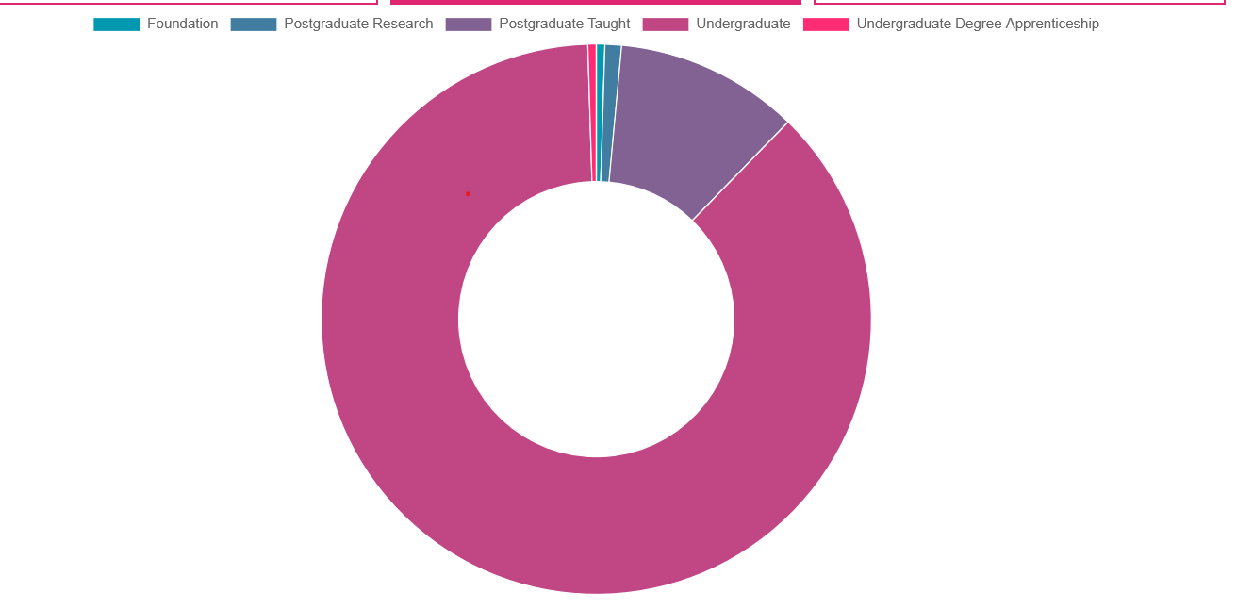
This Society Notes:
- The overwhelming majority of our society is made up of undergraduates, despite there being a large cohort of postgraduate students (approx. 300). Postgraduate students do not interact with the society on a frequent basis.
- Postgraduate students often have different academic and social needs compared to Undergraduates, which may not always be addressed or be practical within the Societies’ general events.
- There is a gap in representation for Postgraduate Students – who unlike undergraduates do not get the opportunity to become Freshers Representatives in their first year, have may have limited time to socialise within the society.
This Society Believes:
- A postgraduate representative will help postgraduate student interaction with the society and help us to be more inclusive of Computer Science students and those interested in the field.
- Increased activity from postgraduate students would enrich the societies diversity and inclusivity.

This Society Resolves:
The following lines should be added to the constitution:

Postgraduate Representative
- The Postgraduate Representative should endeavour to facilitate and drive Postgraduate engagement and events within the society.
- The Postgraduate Representative should act as a first point of contact between Postgraduate students and the Executive Committee.
- The Postgraduate Representative should help and create a welcoming atmosphere for Postgraduate members of the society by hosting varied events to create community with support from the Executive Committee.
- This office will be elected in a by-election or EGM run between weeks one to five of term one.
- The Postgraduate Representative will hold their position until the reset of Society Memberships at the start of September, such that they act as a continuing point of contact in the interim between the AGM and the next Postgraduate Representative elections in Term one.
The following lines should be changed in the constitution under section 6.3.1:
6.3.1 President, Treasurer, Sports Officer, and Ball Officer and Postgraduate Representative shall be filled by one (1) seat. Secretary, Welfare, and Publicity shall be filled by up to two (2) seats. Academic, Gaming, and Social shall be filled by up to three (3) seats. Technical Officer shall be filled by up to four (4) seats. Additional positions should be filled in accordance with 6.3.2.
The following lines should be added in the constitution under 6. Elections:
- Postgraduate Representatives positions are recognised as protected positions, restricted to only Postgraduate students. Voting for Postgraduate Representative positions shall be exempt from quorum.

